**PHYSICAL MODELLING OF WASHBOARD EFFECT ON UNPAVED ROADS**

**Laura Ibagón[1],2; Bernardo Caicedo[2]; Juan P. Villacreses1,2; Fabricio Yepez1**

**ABSTRACT**

*Washboard or corrugation is a common phenomenon in unpaved roads. The washboard effect can be very uncomfortable for the driver, but it can also be very dangerous due to the loss of contact between the wheels and the road. There are few pieces of research about this topic, but undulations seem to emerge due to the car´s velocity and mass. This work aims to identify the main physical variables controlling the appearance of the washboard effect. For this purpose, an experimental set-up of a multi-pass system was developed. This apparatus consists of a rotating wheel rolling over a sandy path. This model allows evaluation of the evolution of the undulations resulting from the washboard phenomenon and allows relating it to variables such as the dynamic forces and track profile. Different scenarios were evaluated, including wheel velocity, wheel mass, and soil density.*

**Keywords:** Washboard effect, soil wheel interaction, critical velocity, soil undulations, soil forces, unpaved roads.

1. **INTRODUCTION**

The washboard or corrugation phenomenon on unpaved roads has been studied since the 1930s in the field of physics and engineering around the world. This worldwide phenomenon produces undulations over granular roads due to the repetitive passage of vehicles, as seen in Fig. 1.

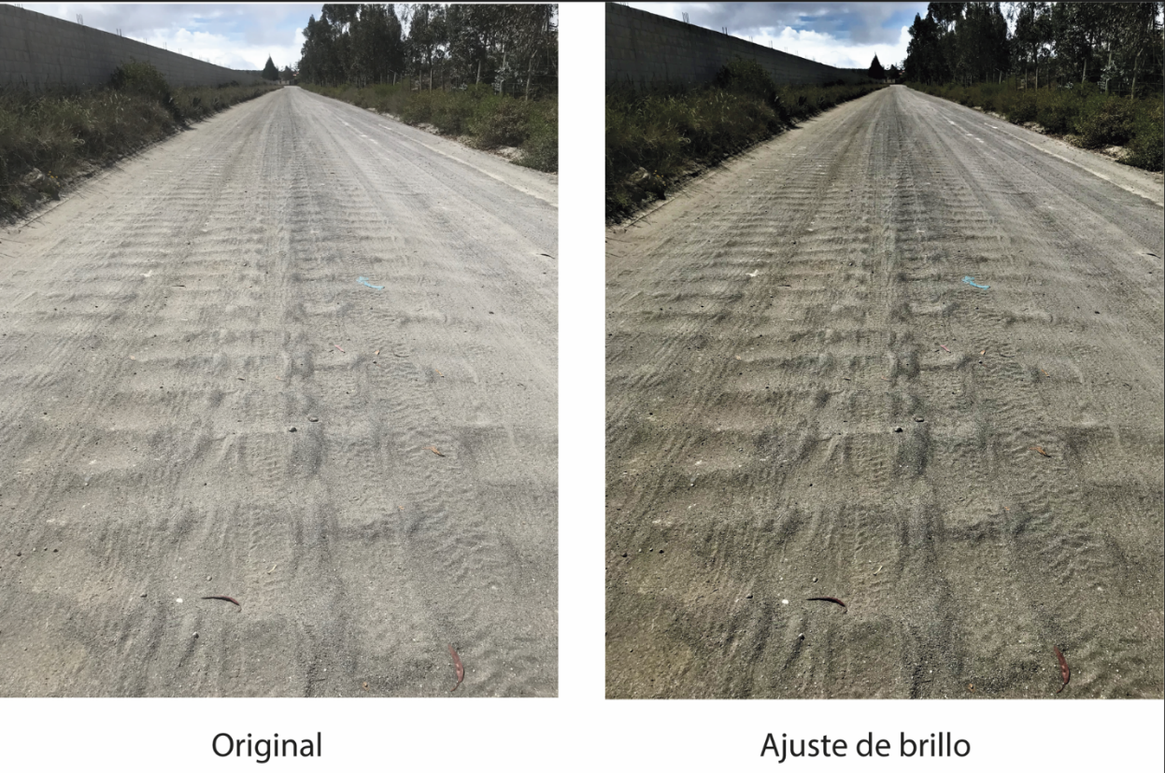

**Fig. 1** Washboard on unpaved roads (Photo from Guayllabamba, Ecuador).

To understand this phenomenon, some theoretical studies have been developed by several authors, some of which are compared with experimental models and field observations. Most of the already conducted research has been developed in granular media. The first of those studies was presented by Relton (1938) and the last one known by the authors was presented by Abu Daoud, et al. (2022). A list of the published studies is presented in Table 1.

Table 1 Previous research list

| **Research** | **Year** | **Material** | **Research type** |
| --- | --- | --- | --- |
| Corrugations on roads (Relton, F.E) | 1938 | Granular | Theoretical model. |
| Why Do Roads Corrugate? (Mather, K.) | 1963 | Granular | Experimental model. |
| Simulation of The Road-Corrugation Phenomenon (Riley, J. G. & Furry, R. B.) | 1973 | Granular | Theoretical and experimental model. |
| Washboards in unpaved highways as a complex dynamic system. (Mays, D.C. & Faybishenko, B.A) | 2000 | Non-specified | Theoretical model |
| Corrugation of roads. (Both, et al.) | 2001 | Non-specified | Theoretical model. |
| Seasonal deterioration of unsurfaced roads. (Shoop, et al.) | 2006 | Granular | Theoretical model and field observations |
| Washboard Road: The Dynamics of Granular Ripples Formed by Rolling Wheels (Taberlet, et al.) | 2007 | Granular | Theoretical and experimental model. |
| Scaling and Dynamics of Washboard Road (Bitbol, et al.). | 2009 | Granular | Theoretical and experimental model. |
| Granular and Fluid Washboards (Hewitt, et al.). | 2011 | Granular and viscoplastic fluids | Theoretical and experimental model. |
| Analysis of factors causing corrugation of gravel roads. (Mahgoub, et al.). | 2011 | Granular | Field observations. |
| Modeling a washboard road: from experimental measurements to linear stability analysis (Percier et al.). | 2013 | Granular | Theoretical and experimental model. |
| Quantifying Roughness of Gravel Roads by Terrestrial Laser Scanning. (Alhasan, et al.). | 2015 | Granular | Field observations. |
| Physical modelling of the washboard effect on unpaved roads (Caicedo, B. & Aguettant, G.) | 2017 | Granular | Experimental model. |
| Dynamics of washboard road formation driven by a harmonic oscillator. (Srimahachota, et al.). | 2017 | Granular | Experimental model. |
| Ripples and grains segregation on unpaved roads. (da Silva, T. & Bernardes, A.). | 2018 | Granular | Theoretical model. |
| Corrugation of an unpaved road surface under vehicle weight. (Matsuyama, et al). | 2020 | Non-specified | Laboratory tests and theoretical model. |
| Studying the effect of gravel roads geometric features on corrugation behavior. (Abu Daoud, O. & Ksaibati, K.) | 2021 | Granular | Field observations. |
| Validating the practicality of utilising an image classifier developed using TensorFlow framework in collecting corrugation data from gravel roads. (Abu Daoud, et al.) | 2022 | Granular | Field observations. |

The most relevant references for the development of this investigation are going to be briefly described. Starting with Relton (1938), who defined the washboard phenomenon as a “relaxation oscillation” behavior generated by stick-slips dynamics. Relton considered that the washboard was developed due to the wheel pushing material ahead of itself. After that, Mather (1963) developed the first experimental model based on field observations. This experimental model consisted of a wheel set in motion over a granular soil surface under controlled conditions (velocity, wheel mass, wheel spring, and soil size and shape particles). As a result, velocity was found as a crucial parameter in the corrugation phenomenon of the soil surface. Riley & Furry (1973) also presented a mathematical and experimental model of a road vehicle system. This mathematical model defined the washboard as a multi-pass phenomenon in which the road profile can be predicted using numerical methods. This model was conceived as a mass-spring-damper system in which different tires’ pressures were numerically evaluated. Those results were compared with an experimental model developed in the laboratory using a pneumatic–tired wheel running along a flat granular surface. This experimental model also showed that the undulation phenomenon is affected by the car’s velocity, weight, and tire inflation pressure. Some years later, Taberlet et al. (2012) reported results from an experimental model and compared them with qualitative soft-particle direct numerical simulations. This research proposed an expression for predicting the normal force of the wheel. In the same way, Bitbol et al. (2009) also proposed a simple experimental model using no spring nor dampers on the wheel, complemented by a theoretical study of the washboard phenomenon. Therefore, in this research, the velocity influence was evaluated as a critical parameter for soil undulations. The critical velocity was described using a scale analysis with a dimensionless ratio. Similarly, Hewitt et al. (2011) proposed a simple theoretical and experimental model. Their experimental results suggested that the washboard phenomenon can occur for just one plow pass at a critical velocity *V*c. This model also showed that the surface material does not need to be granular for wave development; indeed, they tested washboard development in viscous and viscoelastic fluids.

Taberlet et al. (2012) proposed to decompose the washboard phenomenon into four modes, shown in Fig. 2; these modes occur as follows:

1. In the ﬁrst stage, the road is smooth, and all the diﬀerent little ripples will be erased if a car rolls at a speed lower than *V*c.
2. In the second stage, increasing the speed after *V*c, the washboard eﬀect appears, but the wheel is always in contact with the path.
3. In the third stage, as the number of passages increases, the ripples are still growing to a certain height and amplitude so that the wheel jumps at the summit of the next ripples.
4. In the fourth stage, for a high number of passages, the in-stability comes fast, and the wheel jumps from one summit to the next one.



**Fig. 2** Stages in the progression of the washboard.

Another type of model was proposed by Matsuyama et al. (2020), who evaluated laboratory consolidation tests. These essays were used to evaluate soil hardness changes due to compression loads in time. This property was evaluated for Keto Soil (i.e., peat soil), which is similar to the unpaved road material in Japan. Keto soil is soft for wet conditions and very hard for dry scenarios. This experimental campaign was complemented with a theoretical model that uses an effective damped harmonic oscillator to simulate the vehicle’s vertical vibration.

More recently, Caicedo & Aguettant (2022) developed an experimental model in which simulations for the washboard effect under different scenarios were developed. This experimental model showed similar results to previous investigations. The difference between this experimental device and the ones that came before is the capability of force measurements that permits to relate load and permanent displacement. They found a strong dependence between the dynamic forces and the wave’s height.

To provide a better understanding of the washboard phenomenon, this research intends to present a detailed analysis of an experimental model that evaluates soil undulations, dynamic forces, and wheel trajectories under different scenarios, such as wheel velocity, wheel masses, and granular soil densities.

This paper is organized as follows; In the first section, an introduction to the washboard phenomenon was developed. In the second section, materials, the experimental setup developed by Caicedo and Aguettant (2022), and the experimental methodology are described. This is followed by the third section, where the experimental results and analysis are shown. Finally, section four presents a brief conclusion.

1. **METHODOLOGY**

**2.1 MATERIALS**

The evaluated soil corresponds to a river sandy soil with some few silt particles with a medium to fine grain size. The particle size distribution was measured according to (ASTM D6913) as can be seen in Fig. 3. The specific gravity was also measured according to ASTM D854, and the computed result was equal to 2.66. Additionally, the friction angle was measured following the ASTM D3080. The result for this test was a friction angle of 31°. For the repose angle, the measured value was near 37°. Tests were carried out with simplified soil conditions corresponding to dry sand placed at different densities.

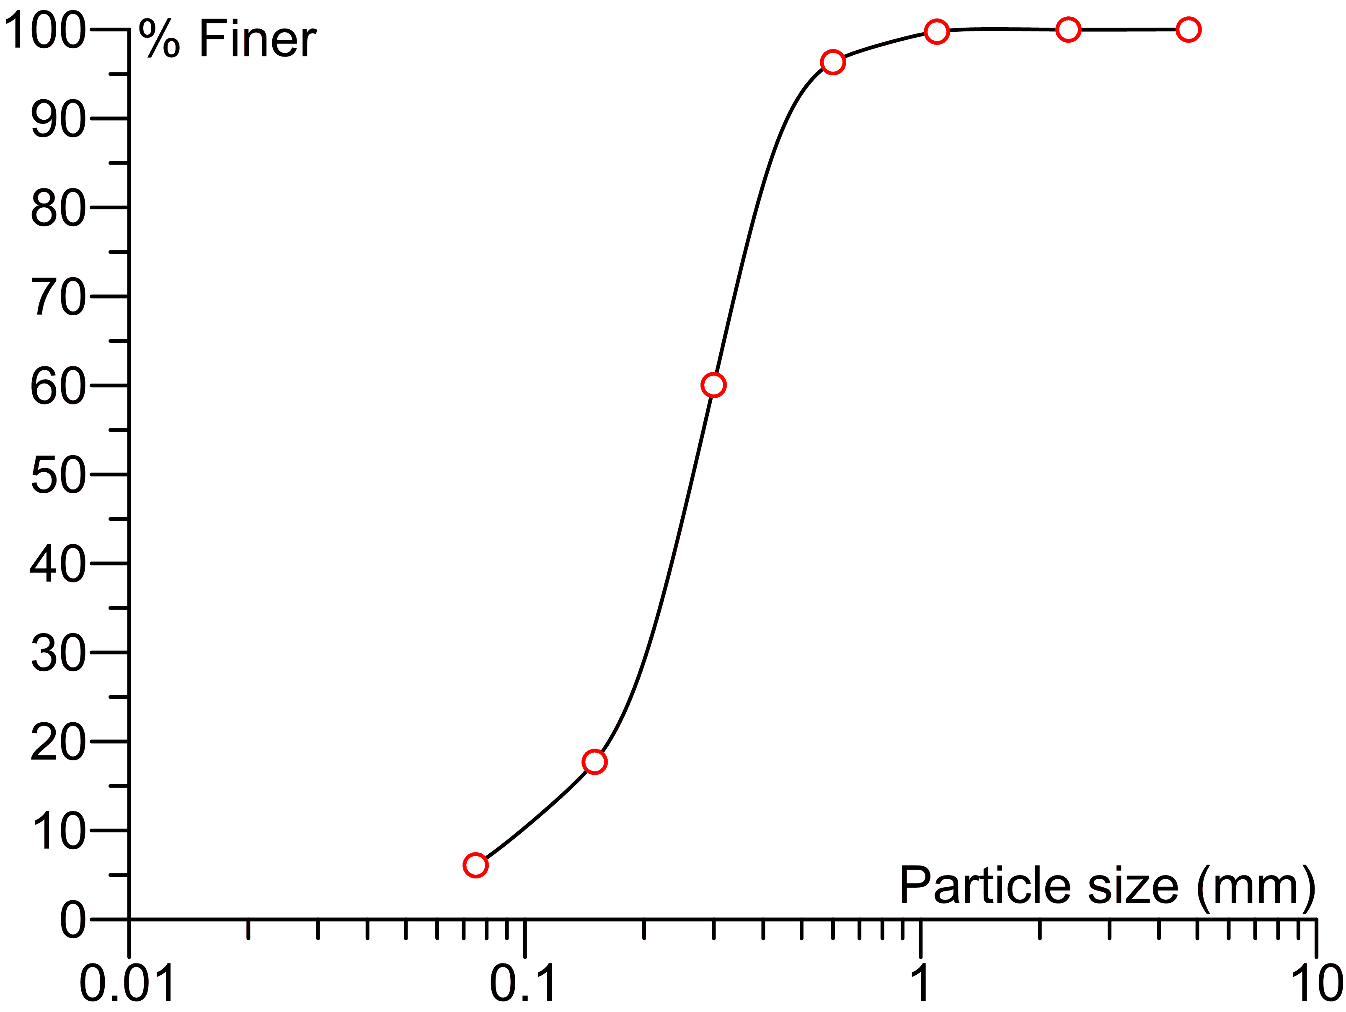

**Fig. 3** Grain Size distribution of the sand

**2.2 EXPERIMENTAL SETUP**

The experimental setup developed by Caicedo and Aguettant (2022) to analyse the washboard phenomenon consists of a circular sandy path on which an instrumented wheel passes over it (Fig.  4). This experimental model allows the measurement of the washboard ripples, resultant soil forces, and wheel trajectory for different scenarios. Those scenarios are variable soil densities, wheel velocities, and wheel masses. The experimental setup has the following components: a circular sand container, a motion system, and an instrumentation and data acquisition system.

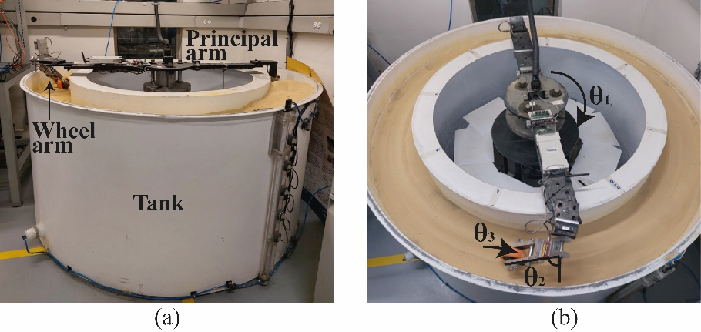

***Fig. 4*** *Experimental Setup (Caicedo and Aguettant, 2022)*

One of the systems that composes the experimental device is a double-wall tank for sand storage whose dimensions are: external and internal diameters of 1.19 m and 1.65 m, respectively, and 0.9 m of depth (see Fig. 4a). The motion mechanism, shown in Fig 4b, is installed in the centre of the tank and allows the repetitive passage of the wheel over the soil, it has two arms: a main arm and a wheel arm. The main arm is driven from a rotation system placed in the centre of the tank, and the wheel arm is placed at the end of the main arm above the sand surface. Those arms allow three degrees of freedom, as can be seen in Fig. 4b. The first degree of freedom ( $θ_{1})$ allows the rotation of the principal arm over a vertical axis placed in the centre of the tank. The second degree of freedom ( $θ_{2})$ allows the wheel arm to move upwards and downwards following the soil surface, and the third degree of freedom ( $θ_{3})$ allows the wheel to roll over the soil.

Additionally, the apparatus has the instrumentation and a data acquisition system shown in Fig. 5. Such system has the following components (Caicedo and Aguettant, 2022):

1. A static disk with holes separated 10° equipped with a proximity laser sensor placed in the main arm. The laser sensor reads the disk holes with an on-off mode working as an encoder that allows computing the angular position of the main arm of the apparatus.
2. Another laser sensor is located in the main arm of the apparatus on the opposite side of the wheel. This sensor is an optic triangulation laser with a measurement range of 100 mm and a resolution of 50 m; it allows observing the evolution of the waves, particularly the wave wavelength and amplitude.
3. A third laser sensor measures the position of the beam-wheel arm; it is an optic triangulation laser with a measurement range of 50 mm and a resolution of 25 m. This sensor permits obtaining the angle of the wheel arm, which allows computing the position of the wheel continuously.
4. Finally, wheel force is measured with a load cell located along the beam carrying the wheel.

The data acquisition system has a wireless unit NI WLS-9163 working at a sampling frequency of 20 KHz for all the sensors. This high frequency permits measuring the dynamic force and the soil profile.



***Fig. 5*** *Layout of the sensors and data acquisition system (Caicedo and Aguettant, 2022)*

**2.3 SOIL PREPARATION AND EXPERIMENTAL PROGRAM**

To achieve different soil densities, the sandy path was compacted using a pneumatic compactor as can be seen in Fig 6. This pneumatic compactor was used to apply energy over the soil until the desired density was achieved. For a soil density of ρ = 1740 kg/m3, the compactor was placed over the soil for one minute per position and was moved around the tank until the whole perimeter was compacted with the same amount of energy. On the contrary, no compaction was needed for a soil density of ρ=1520 kg/m3.

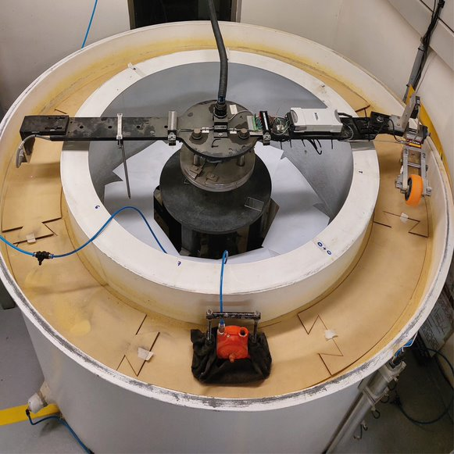

***Fig. 6*** *Compaction procedure to increase the density of the layer.*

A total of 15 experiments were conducted under different scenarios to analyze the washboard phenomenon on unpaved roads. Those scenarios were developed by combining different wheel velocities, soil densities, and wheel masses. The evaluated combinations are presented in Table 2. All the conducted experiments were carried out on dry sand using the device presented in section 2.2.

**Table 2** Conducted experiments

|  |  |  |  |  |  |  |  |  |  |
| --- | --- | --- | --- | --- | --- | --- | --- | --- | --- |
|  |  | Wheel velocity (m/s) | | | | | | | |
|  | | 0.52 | 0.78 | 1.03 | 1.29 | 1.55 | 2.08 | 2.61 | 3.15 |
| Soil density (kg/m3) | 1520 | x |  | x |  | x |  | x |  |
| 1740 | x | x | x | x | x | x | x | x |
| Wheel mass (g) | 1200 |  |  |  |  |  | x |  |  |
| 1331 |  |  |  |  |  | x |  |  |
| 1475 |  |  |  |  |  | x |  |  |

1. **RESULTS AND ANALYSIS**

Towards a better understanding of the wheel–soil interaction in the washboard phenomenon, this section analyses four aspects of the corrugation results of the track path: (i) the emergence of waves depending on the wheel velocity, (ii) the dynamic contact forces, (iii) the interaction between the wheel and the track surface and (iv) a frequency analysis dealing with the evolution of wavelengths as the number of wheel passages increases. Finally, the effect of wheel mass and soil density is examined.

**3.1 PERMANENT DISPLACEMENT**

The first variable that shows the washboard evolution is wave amplitude. Fig. 7 presents the peak-to-peak mean amplitude depending on the number of passages for a test with soil density of 1740 kg/m3, velocities of 0.78 m/s, 1.29 m/s, 1.55 m/s, and 2.08 m/s, and wheel mass of 1200g. It was observed that the amplitude grows as the wheel passes over the sandy path increases, and its magnitude is also related to the wheel’s velocity. This behaviour was only valid for cases where the wheel velocity was higher than the critical. Otherwise, almost constant waves appeared in any passage, as can be seen in Fig 7 for a wheel velocity of 0.78 m/s. On the other hand, amplitudes for a wheel velocity of 2.08 m/s are higher than the measured values for 1.55 m/s, and those are higher than the ones measured in the 1.29 m/s experiment.

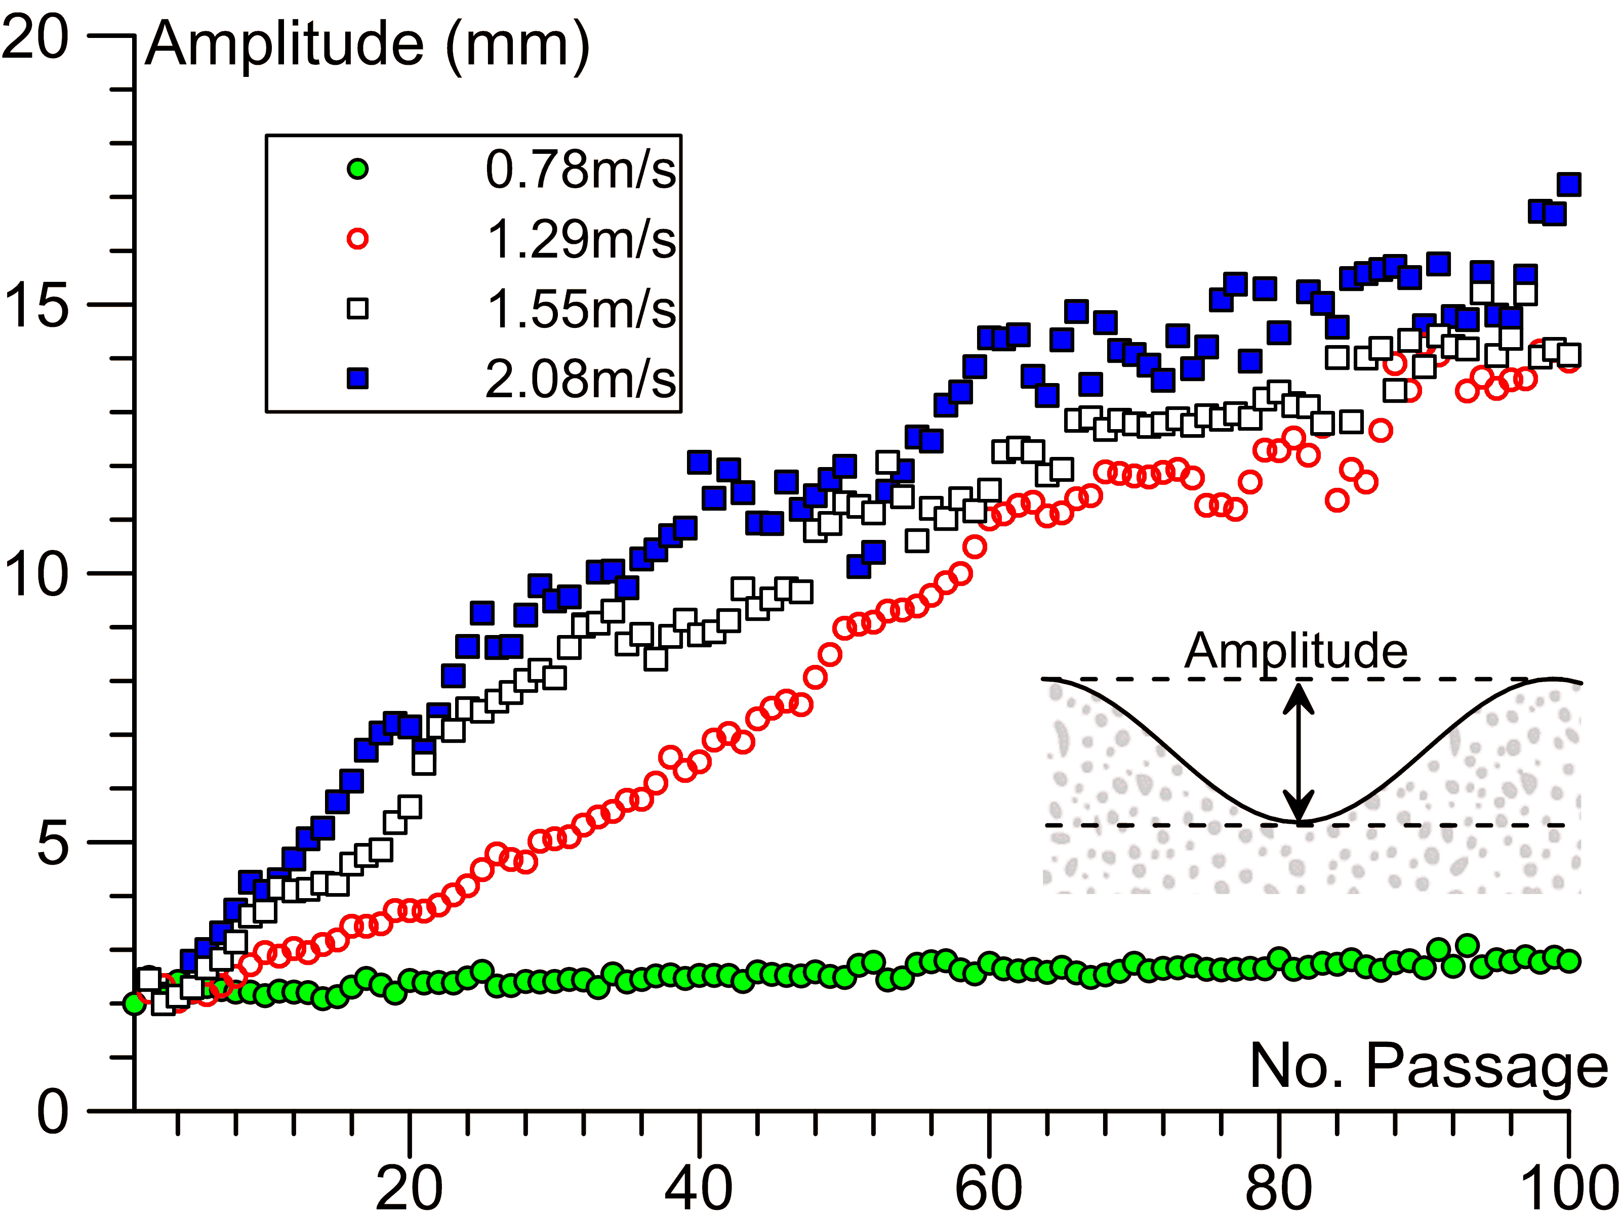

***Fig. 7*** *Average amplitude for multiple wheel passages*

Fig. 8 shows the amplitude of the waves, computed as the average of the soil displacement on peaks and valleys, measured for eight different velocities. Also, the standard deviation was computed as a dispersion measure for those measured amplitudes. Those variables were computed for each test in the 80th passage of the wheel. Fig. 8 suggests that there is a relation between the wheel velocity and the average of the sand ripples. For higher wheel velocities, bigger waves appeared in the granular path. That general behaviour agrees with Bitbol et al. (2009), Hewitt et al. (2011), Taberlet et al. (2012), and Caicedo & Aguettant (2022). Fig 8 permits us to assess the critical velocity from which undulations started to appear (*Vc* ≈ 1.0 m/s). It is interesting to note that at high velocities (i.e., 3.15 m/s), the amplitude of the waves decreases. This behaviour appears because when the wheel impacts the crest of the wave at high velocity, it flattens the peak of the waves.

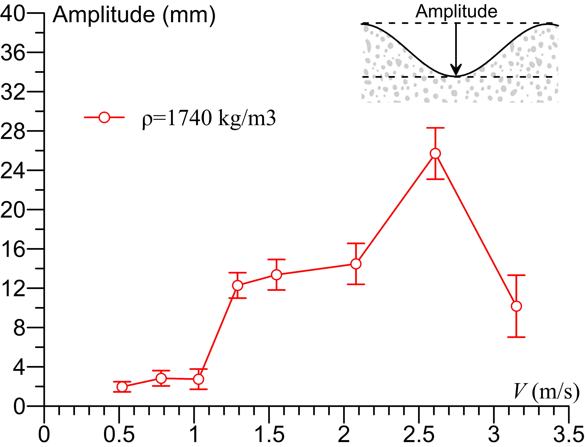

***Fig. 8*** *Average indentation results for soil density of 1740 kg/m3, wheel mass 1200 g.*

An analysis of the wave’s propagation in terms of the number of wheel passages showed that the undulations are related to the wheel’s velocity. Fig. 9 shows the evolution of the soil profile deformations in terms of the number of wheel passages for a velocity of 2.08 m/s and 0.78 m/s. For a velocity of 2.08 m/s, the soil profile seems to remain safe for the driver during the first 10 passages, and after that, bigger waves started to appear. For example, undulations near 3 mm were registered for the first 5th passages, while deformations near 30 mm were measured in the 80th passage. The wave amplitude grew and the unpaved road seems to become uncomfortable and unstable. This means the wheel jumped during the experiment due to the velocity and the washboard. In contrast, for a velocity of 0.78 m/s (i.e., lower than the critical), no undulations nor wheel jumping were recorded. That means the shape of the sand profile barely changes during the eighty passages of the wheel. However, it was observed that the soil profile tends to settle and goes down due to soil compaction produced by the passage of the wheel.

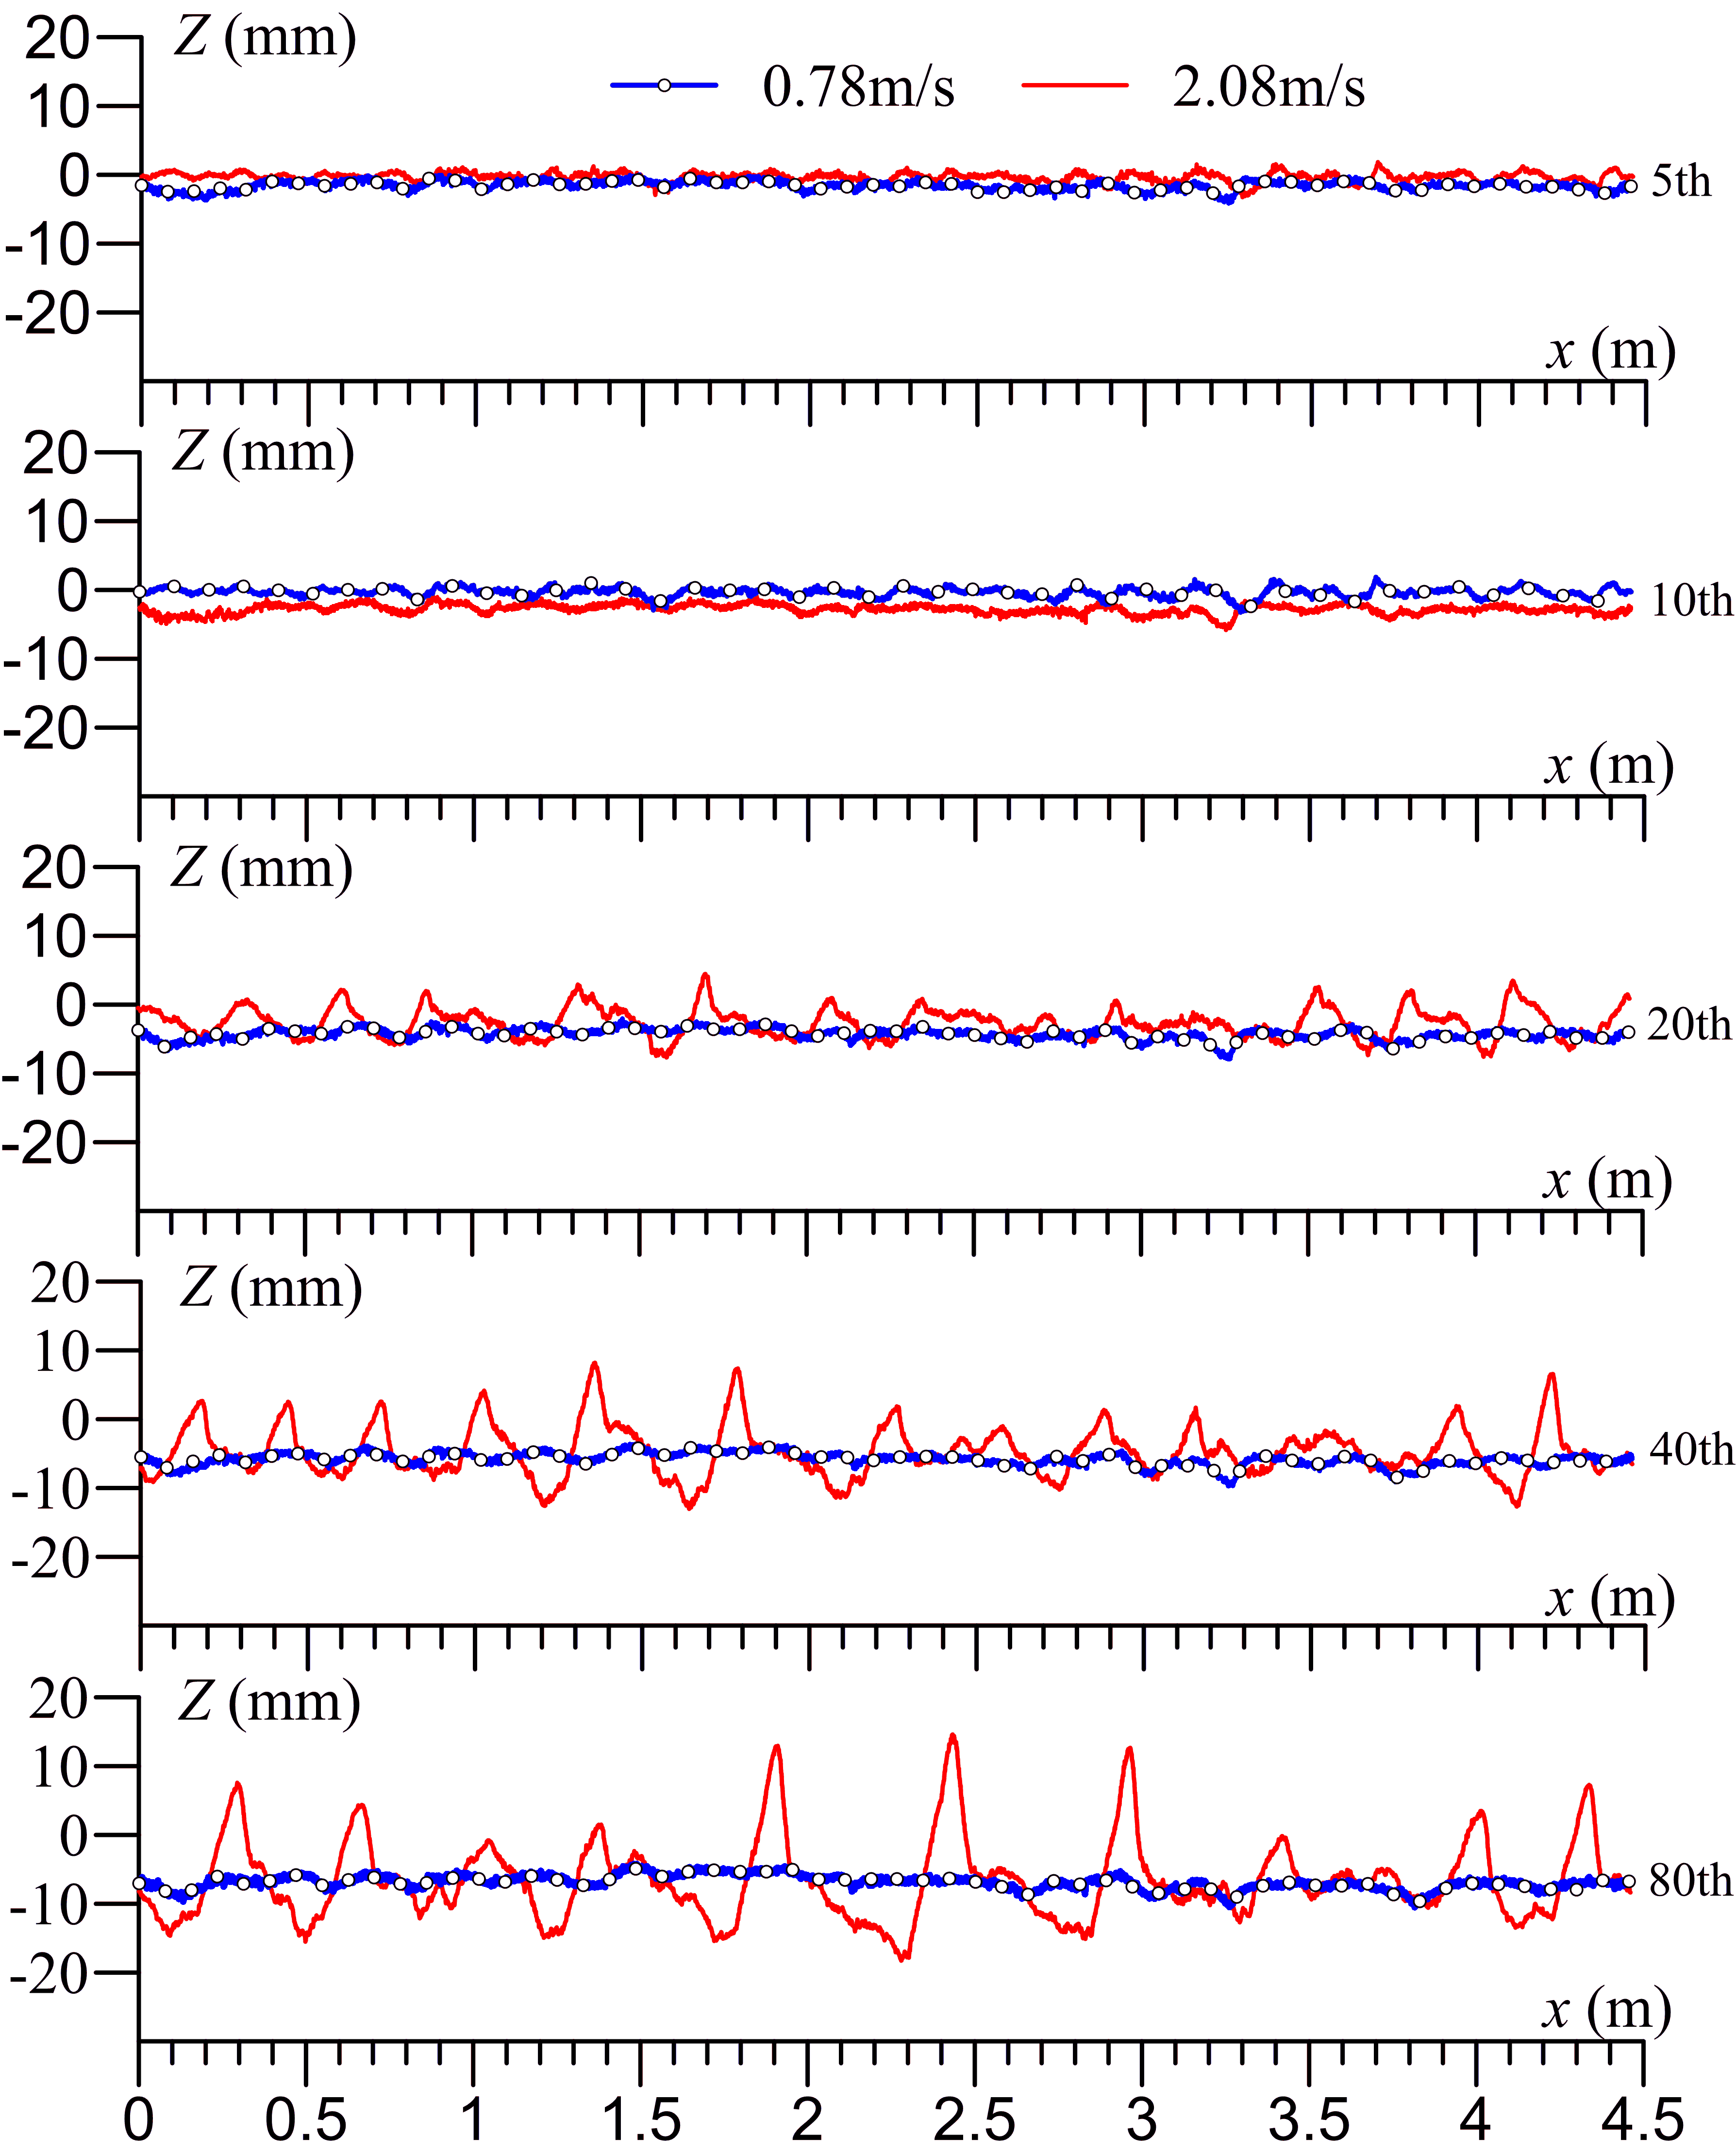

***Fig. 9*** *Soil profile for multiple wheel passages and variable velocities*

Figs. 10 (a, b) show the evolution of a particular wave in the track and its horizontal displacement for different passages of the wheel for velocities of 0.78 m/s and 2.08 m/s. A few millimeters of soil permanent displacement were measured for the low velocity and almost no wave movement was registered. However, the soil profile tends to settle and as the wheel passes this settlement increases. Then, for the 80th passage, the soil profile is almost 1 cm below the initial soil profile level. In contrast, for a velocity of 2.08 m/s, the analyzed wave started to appear in passage number 10 and grows bigger for the subsequent wheel passages. This wave also moved forward almost 20 cm as the wheel passed over the sandy path. Therefore, the center of the crest began at an *x* position of 1.7m in the 10th passage and ended at 1.92 m in the 80th passage.

Similarly, another particular wave was analyzed for the soil profile in the 2.08 m/s wheel velocity experiment. For this experiment, the wheel passage number 280th was chosen due to the highly measured soil deformations (Fig. 11). As a result, it was found a different value for the upward and the downward slope. The measured upward slope was 17.2° while the downward slope was 34° (measured from a horizontal line). The upward slope is lower than the repose angle, i.e., 37°, but the downward slope approaches it.

|  |  |
| --- | --- |
| (a) | (b) |

***Fig. 10*** *Evolution of particular waves. (a) 0.78 m/s wheel velocity. (b)2.08 m/s wheel velocity*

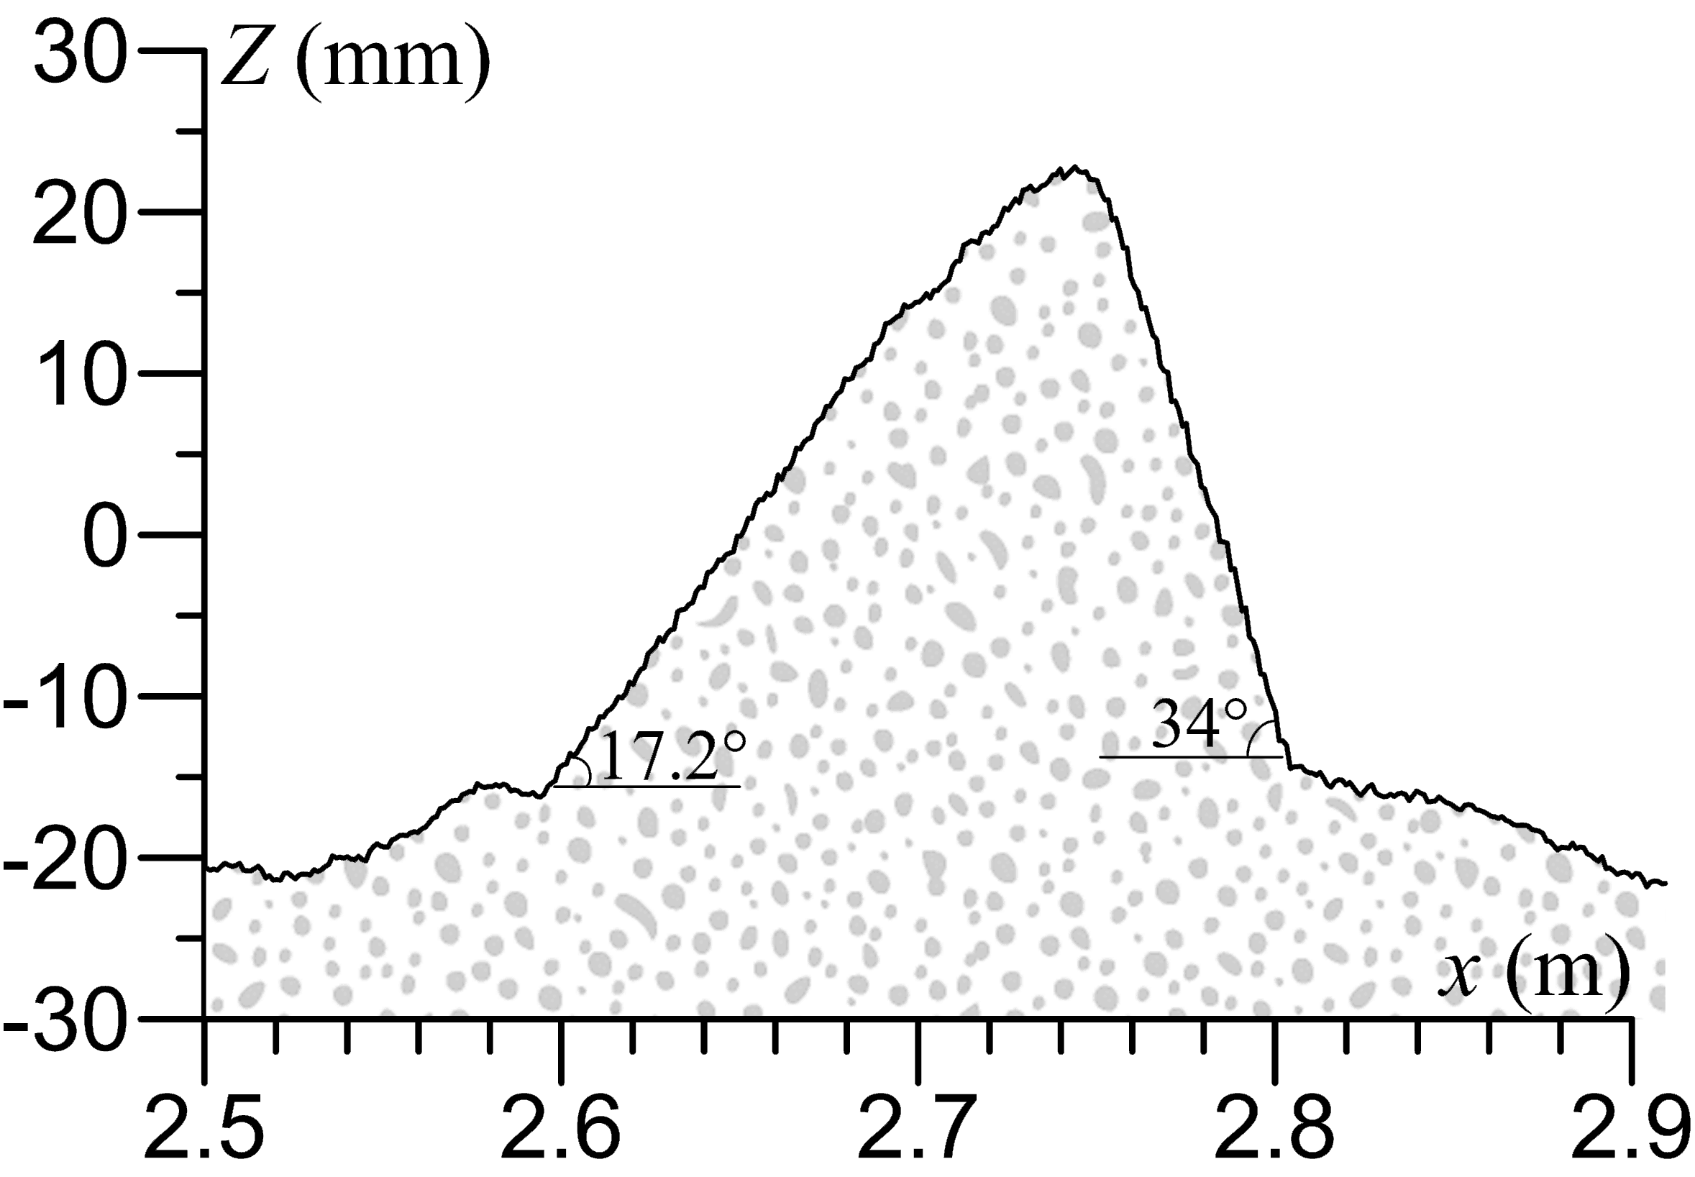

***Fig. 11*** *Particular wave for 2.08 m/s wheel velocity, 280th wheel passage.*

**3.2 DYNAMIC LOADS**

For the evaluated scenarios, soil reacting forces were also measured, as can be seen in Fig. 12. Those results correspond to a wheel velocity of 2.08 m/s and 0.78 m/s, with a soil density of 1740 kg/m3 and different wheel passages (i.e., 5, 20, and 80). For a velocity of 0.78 m/s, the forces are almost constant and near zero. This is due to the low velocity of the wheel. As was explained before, for velocities lower than the critical, no waves were seen in the sandy path. That means that the wheel was in contact with the soil the whole experiment, and no upward and downward movements were seen. Therefore, no tension nor compression variations in the load were recorded.

On the contrary, for a wheel velocity of 2.08 m/s, the soil forces present negative values that are associated with compression and positive values that refer to tensile forces. This behaviour is explained by the trajectory of the wheel. For those positions in which the wheel is in contact with the soil after an impact, the measured force is going to be negative for compression, while there are some positions where the wheel is flying, and tensile forces are reported. Moreover, force values increase with the number of passages. That can be attributed to the soil deformations in each passage. For example, during the 5th wheel passage, the forces oscillated between 10 and -40 N, while for the 80th passage, forces ranged between 40 and -160 N. That means there was an increment of 75%. As a result, deeper waves and higher crests appeared, meaning higher jumps. Consequently, bigger forces are going to be recorded by the load cell. Those recorded forces do not include the arms and wheel self-weight.

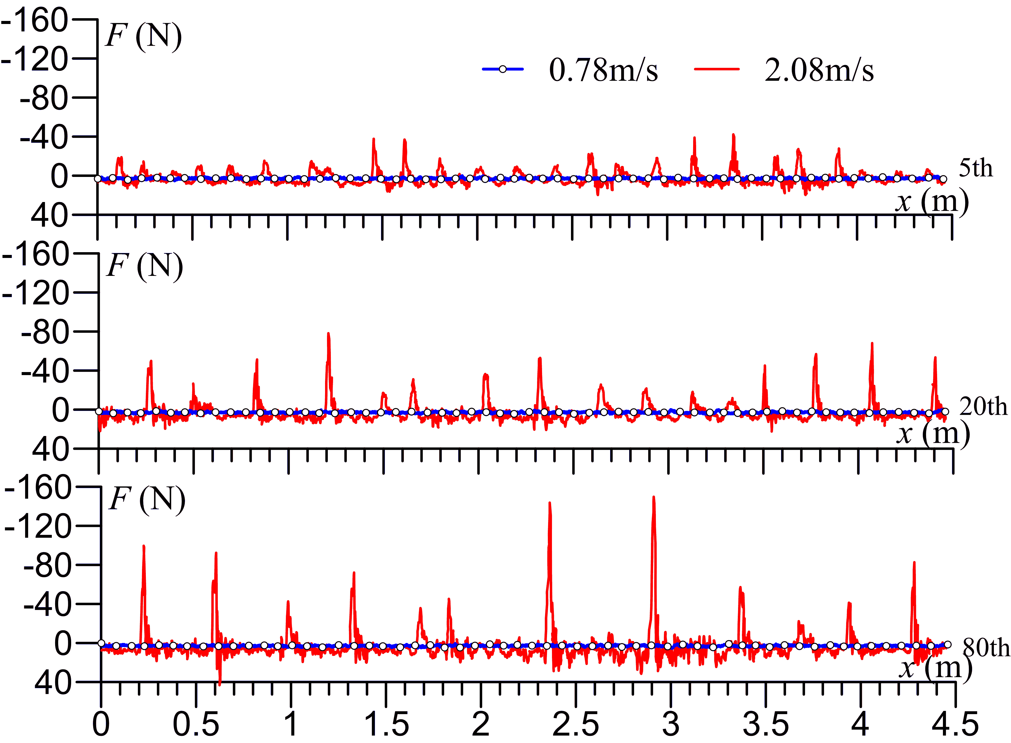

***Fig. 12*** *Measured forces for multiple wheel passages and variable velocities.*

**3.3 INTERACTION BETWEEN LOADS AND TRACK PROFILE**

This section allows a better understanding of the wheel–soil interaction in the washboard phenomenon by analyzing together the soil displacement, the soil reaction forces, and the wheel trajectory.

Changes in the soil profiles and soil resulting forces are presented using contour plots (Fig. 13) for a wheel velocity of 0.78 m/s and 2.08 m/s. In Fig. 13 (a,c), the evolution of the soil profile is analyzed as the upwards and downwards slope of the waves (i.e., gradients). For a wheel velocity of 0.78 m/s and 110 passages (Fig. 13 a), little waves were observed. The computed gradient values ranged between -0.03 and 0.03. There is a particular zone of the path with a slightly higher gradient, which means higher soil deformations took place at a position of *x*=3 m from the beginning of the test. Moreover, the waves seem to maintain their position in each passage (i.e., almost vertical lines can be observed in the soil profile plot), and the behaviour tends to be stable after the first 40 wheel passages. Similarly, forces seem to be small and constant during the whole experiment, with values that ranged between 2 and 3 N (see Fig. 13b).

In contrast, for a wheel velocity of 2.08 m/s and 330 passages (Fig. 13 c), the computed gradient values ranged between -0.6 and 0.4. It was also observed that the waves move forward in the sandy path as the wheel passes over (i.e., tilted lines can be observed in the soil profile plot). That means that the sand was displaced a few millimeters due to the wheel’s movement during the multiple passages. This behavior was also observed by Bitbol et al. (2009), Hewitt et al. (2011), and Taberlet et al. (2012). In the same manner, measured forces ranged between 26 and -140 N (Fig. 13 d). Those forces showed negative values for compression when the wheel is in contact with the soil, while positive values were registered for tension when the wheel flew. Then, a force profile that follows the soil ripples is expected. During this experiment, the wheel flew multiple times.

|  |  |
| --- | --- |
| (a) | (b) |
| (c) | (d) |

***Fig. 13*** *Soil profile gradient and forces. (a) Soil profile gradient 0.78m/s. (b) soil forces 0.78 m/s. (c) soil profile gradient 2.08 m/s (d) soil forces 2.08 m/s*

Knowing that the wheel’s velocity defines the soil behavior, the soil profile and the magnitude of the resulting forces for the 5th and 80th passage of the wheel are analyzed together in Figs. 14 and 15.

|  |  |
| --- | --- |
|  | ***Fig. 14*** *Soil profile, forces, and wheel trajectory 0.78 m/s wheel velocity and 5th and 80th passages.* |

These results showed that the forces can be directly related to soil deformation. That means, with the wheel’s velocity and the number of passages of the wheel. Therefore, for a velocity of 0.78 m/s (i.e., velocity lower than the critical), little soil deformations and small forces were registered. No tension nor compression forces were measured because almost no jumps of the wheel were seen, and no clear impact was reported (Fig. 14). On the contrary, for a wheel velocity of 2.08 m/s (i.e., velocity higher than the critical), undulations were seen, and higher soil resultant forces were measured. Therefore, the wheel jumped over the sandy path several times. This behavior also increased as the wheel passes over. During the 5th passage, the wheel rolled and also jumped over the soil. As a result, recorded forces oscillated between 15 N for tensile forces and -40N for compression. For the 80th passage, the waves’ amplitude was even higher. Therefore, the wheel jumped higher, and bigger forces than the ones measured in the 5th passage were registered. The measured forces ranged between 25N for tensile forces and -110 N in compression (Fig. 15).

|  |  |
| --- | --- |
|  | ***Fig. 15*** *Soil profile, forces, and wheel trajectory 2.08 m/s wheel velocity and 5th and 80th pasaages.* |

**3.4 FREQUENCY ANALYSIS**

To analyze the experimental results, a power spectral density (PSD) was computed on the 100th passage (Fig. 16). The results confirmed that the wavelength is related to the wheel velocity. That means, for higher velocities, lower 1/λ were found, which implies wider waves were registered for that particular passage. For example, for a wheel velocity of 1.29 m/s, the PSD showed a dominant 1/λ of 4.5 m-1, with a power spectral value of 12 mm2s2. That means the dominant registered λ is 0.22 m. For a higher wheel velocity of 1.55 m/s, the dominant 1/λ was 3.3 m-1 with a power spectral value of 16 mm2s2. This result is lower than the one computed previously. Therefore, a longer dominant wavelength was registered (i.e., λ of 0.30 m). Finally, for a wheel velocity of 2.08 m/s, the dominant 1/λ was 1.88 m-1, with a power spectral value of 15 mm2s2. However, there was another peak for a 1/λ of 2.46 m-1 with a power spectral value of 10.16 mm2s2. In this case, both dominant 1/λ follow the same trend and are lower than in the previously explained examples. Which implies that λ ranges between 0.4 and 0.5 m.

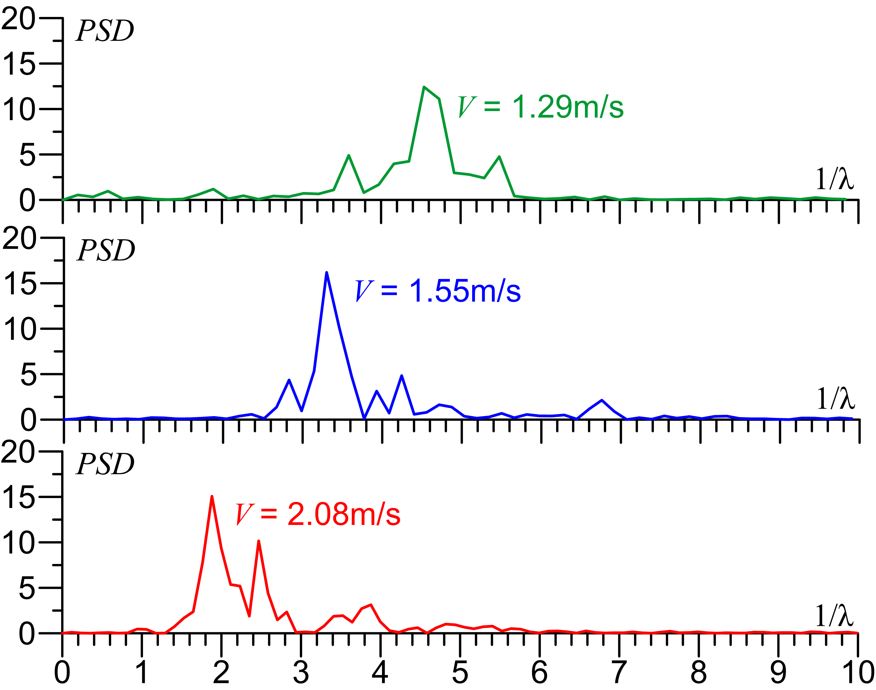

***Fig. 16*** *Power spectral density for variable wheel velocities and 100th wheel passage*

Another analysis was developed in terms of frequency and time using wavelets for data collected during the whole experiment of 1.29 m/s, 1.55 m/s, and 2.08 m/s (Fig. 17). As a result of the wavelet computation, dominant frequencies were obtained in terms of time, and time can be easily related to wheel passages. Wavelets can be used to compute the wavelength, as the inverse of frequency times the wheel velocity. The results showed that the wavelength increases in time as the wheel passes over. As an example, for a wheel velocity of 1.29 m/s, the scalogram does not show a clear dominant frequency for the first 80 seconds of the experiment. However, after this time, a frequency of 12 Hz begins to appear as a dominant one with a wavelet coefficient of 5. This behavior was seen until the second 400. After that, from the second 400 to the 700, a lower dominant frequency of 10 Hz started to appear, with higher wavelet coefficient than before. That means most of the waves’ length grew during the last 300 seconds of the experiment.

For a wheel velocity of 1.55 m/s, a similar behavior was found. In the beginning, no clear dominant frequency was found. However, after the first 50 seconds, a dominant frequency of 14 Hz appeared, with a wavelet coefficient of 2. Later, from the 200th second to the 400th, the dominant frequency decreased and took a value of 12 Hz with a wavelet coefficient of 5. After that, from the 600th second to the 700th, the dominant frequency decreased again until a value of 9 Hz with a wavelet coefficient of 12. Those changes mean the waves followed three different dominant frequencies and increased their length three times during the experiment. The dominant frequencies for this experiment are lower than the ones registered for a wheel velocity of 1.29 m/s. That means the wavelength is higher for this experiment.

Finally, for a wheel velocity of 2.08 m/s, the same behavior was found. In the beginning, no clear dominant frequency was found. However, as the wheel passed over the sandy path, a dominant frequency of 8Hz started to appear with a wavelet coefficient of 8. This dominant frequency became stronger as time passed, and for the last 300 seconds of the experiment, it reached a wavelet coefficient of 16. Additionally, at the same time, from the second 400 to the second 700, another dominant frequency of 14 Hz appeared. That suggests there was a variable wavelength during the last 300 seconds of the experiment.



***Fig. 17*** *Scalogram for variable wheel velocities. (a)1.29 m/s, (b)1.55 m/s, (c)2.08 m/s.*

* 1. **EFFECT OF DENSITY AND MASS**

Fig. 18 suggests there is a relation between the wheel velocity, the soil density, and the average and standard deviation of the amplitude of sand ripples. The deepness of those ripples is directly proportional to the wheel velocity, and it is also related to the soil density. For higher wheel velocities, deeper waves are going to be seen in the granular path. That general behavior agrees with Bitbol et al. (2009), Hewitt et al (2011), Taberlet et al. (2012), and Caicedo & Aguettant (2022). The figure also suggests there is a critical velocity from which undulations started to appear (i.e., 1.0 m/s). Therefore, it appears that soil density is not a crucial parameter to define this critical velocity. However, soil undulations deepness seems to depend on the soil density. As it was expected, higher deformations were measured for soils with lower density. Density also affects the dispersion of the measured undulations.

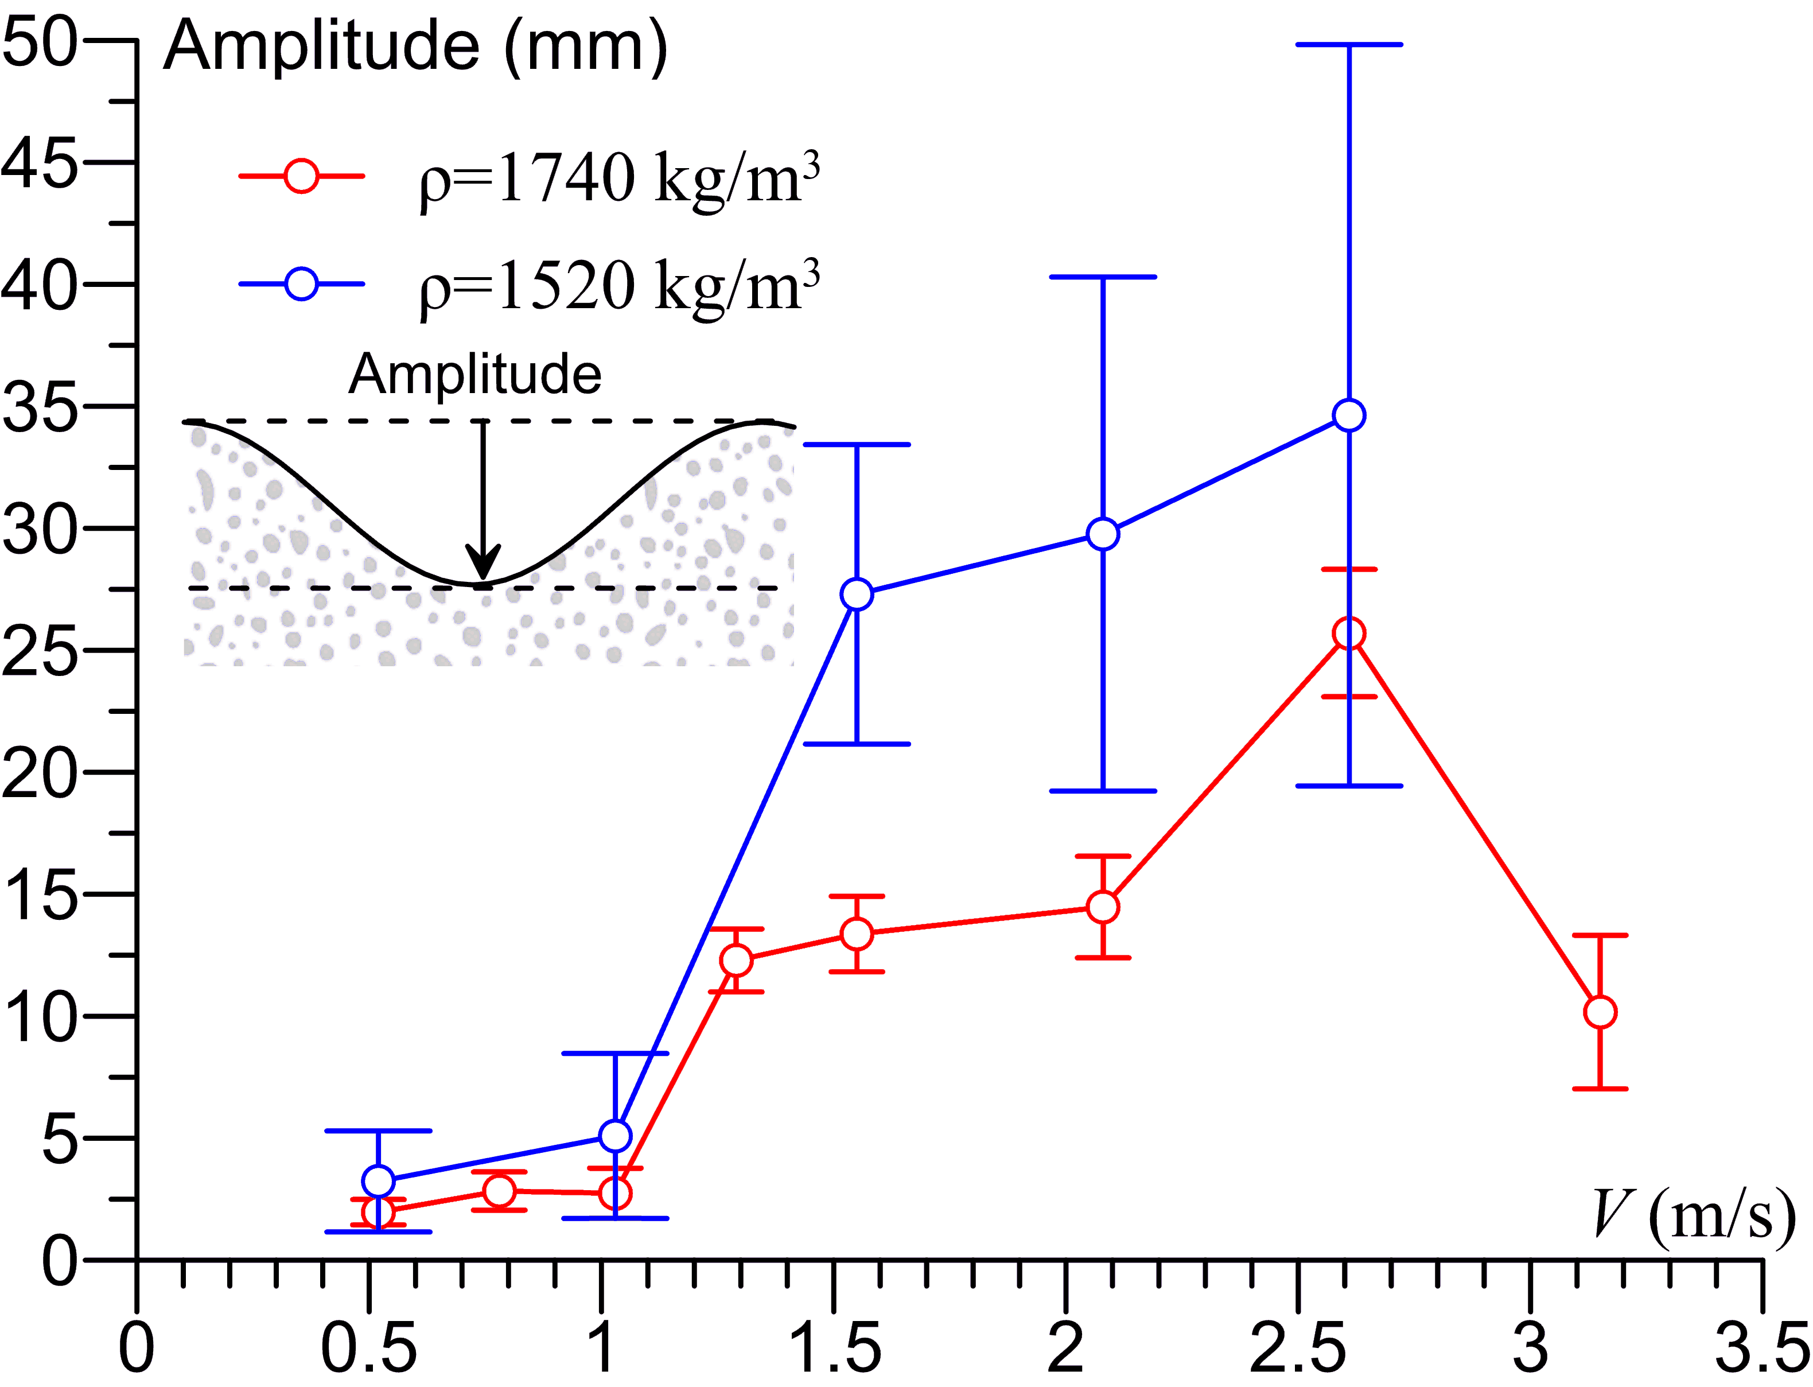

***Fig. 18*** *Wave’s amplitude for soil density of 1740 kg/m3 and 1520 kg/m3.*

The effect of additional masses placed in the wheel arm was also evaluated. Experiments with three different masses (1146, 1331, and 1475 g), a constant velocity (2.08 m/s), and a sand density of 1520 kg/m3 were conducted. Fig. 19 shows the mean and the standard deviation of the soil undulation in the 80th passage of the wheel. Results suggest that the undulations' deepness is related to the mass. As can be seen in the results, deeper undulations were measured for higher masses as it was expected.

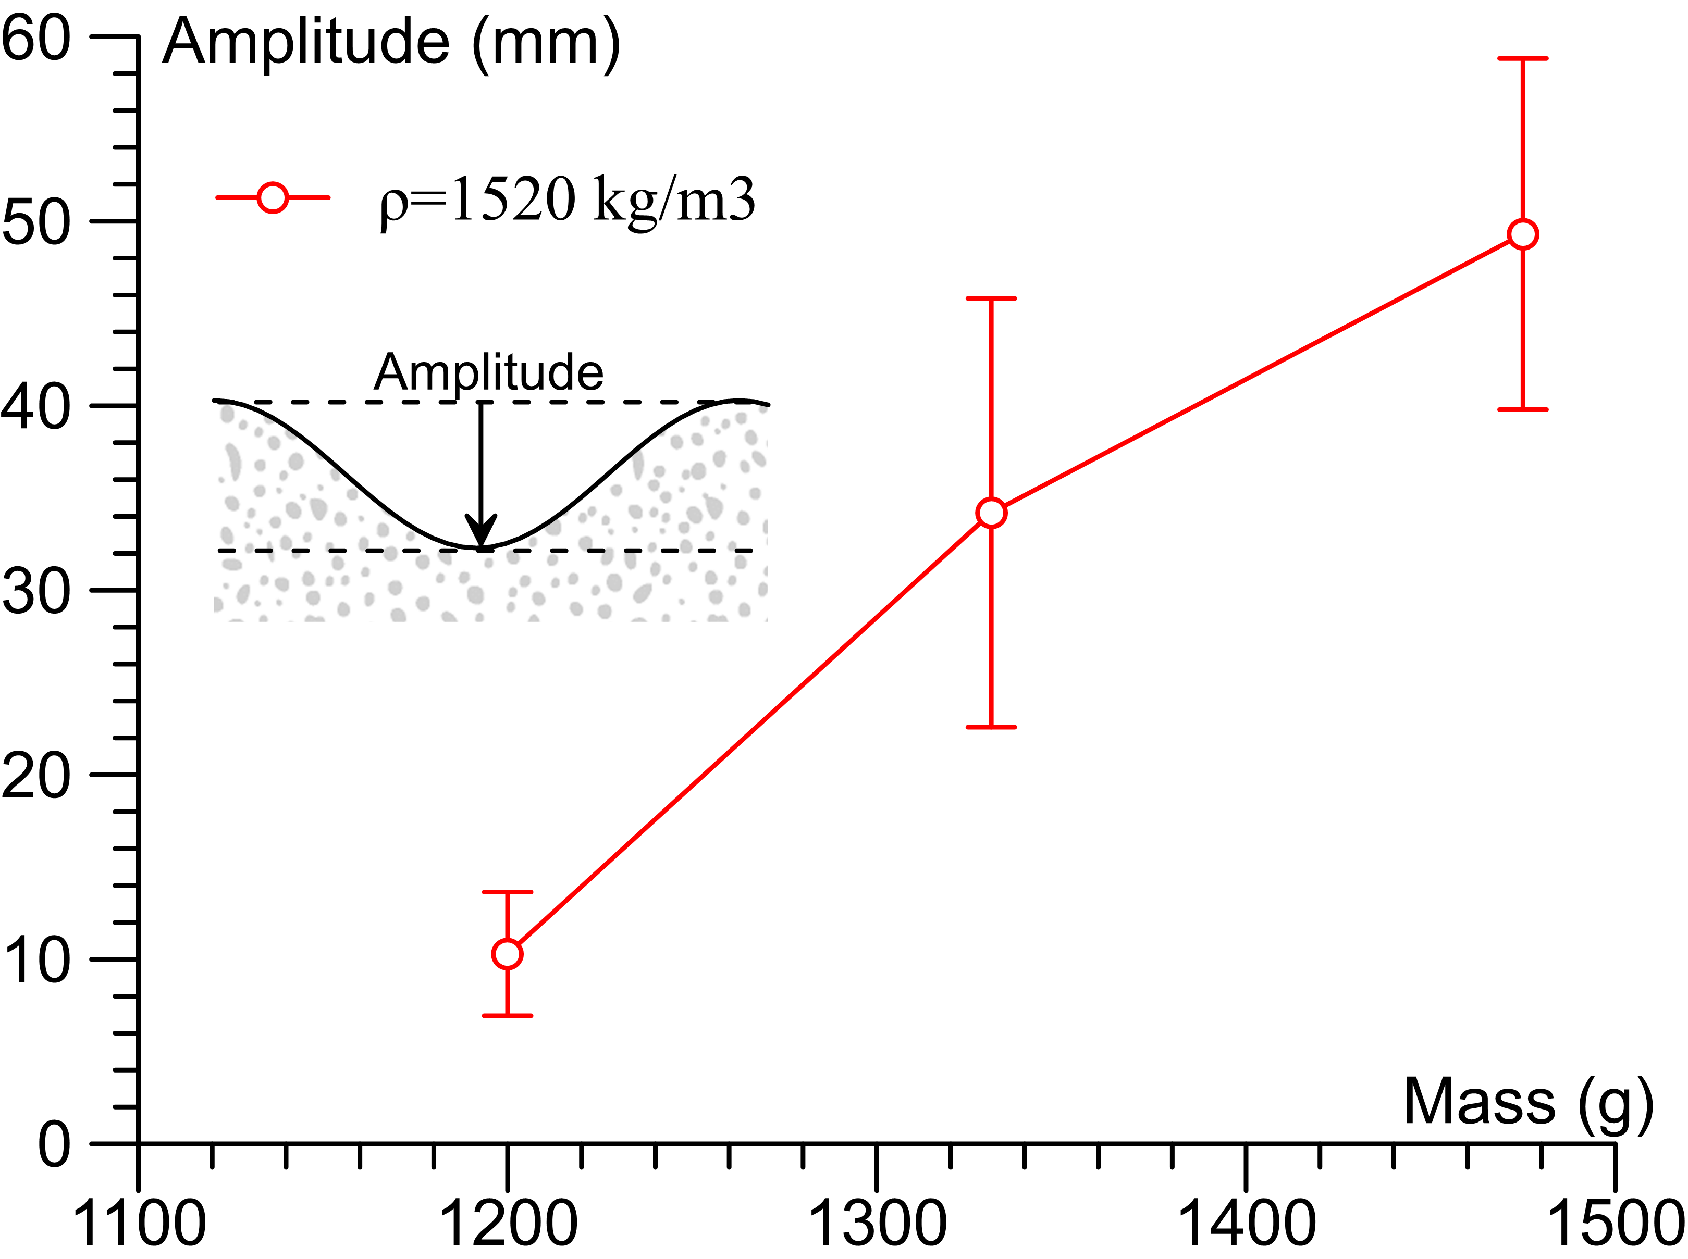

***Fig. 19*** *Waves amplitude for variable wheel masses and velocity of 2.08 m/s.*

**3.6 LIMITATIONS**

The findings of this study gave some important insights to understand the washboard phenomenon on unpaved roads, but they are evaluated to a simple model of cohesionless sand. This is due to the complexity of the system in which dynamical interactions, plastic deformations, and forces need to be well understood. The experimental model does not represent a real pavement structure. Because of this, measured results can not be directly applied to real situations due to the reduced scale nature of the model and because of the limited compacted state of the sand. Future studies will evaluate the soil cohesion and compaction effect on the washboard phenomenon. Additionally, to understand the real-scale washboard, experimental evaluations of the undulations are going to be measured in real tracks of unpaved roads with the washboard phenomenon. This evaluation is going to be developed with the same methodology used in the reduced-scaled model explained earlier. These new experimental measurements will help to understand the force and the wheel-soil interaction for different types of soil.

1. **CONCLUSIONS**

This article presented an experimental evaluation of the washboard phenomenon under different scenarios such as wheel velocity, soil density, and wheel mass using an experimental multi-pass model. The results contributed to the insight into the corrugation in unpaved roads. Moreover, this research validates previous findings pointed out by earlier investigators and proposed new relationships.

The results obtained from this work were presented in terms of soil deformations, soil forces, and wheel trajectories. It was found that soil undulations features are mostly related to the wheel velocity. That means wave amplitude and length are bigger for those evaluated scenarios with high wheel velocity. Undulations appeared only for the tested velocities that were higher than the critical (i.e., 1m/s). Additionally, soil densities and wheel masses were evaluated. It was found that the soil undulations are deeper for the looser sand and higher wheel masses also seem to generate deeper waves. For the analyzed scenarios it was also seen that wave amplitude grows as the wheel passes over the sand. This behavior was seen in all the conducted experiments.

The registered forces were also in agreement with the undulated soil profile for different wheel velocities. When the velocity was lower than the critical, the wheel was in contact with the soil the whole experiment, and no upward and downward movements were registered. That means force values were kept almost constant during the multiple wheel passages. However, for the scenarios with higher wheel velocities, the wheel rolled over the sand and also flew. Negative forces were registered as compression for those wheel-soil contact positions, while positive forces are related as tension during the flying positions. Forces values increased with increasing velocities and an increasing number of wheel passages.

Another important analysis was developed in terms of changes in the soil profile as the wheel passes over the soil. It was found that the waves tend to move forward in the same direction as the wheel. That behavior was only seen for wheel velocities higher than the critical. Consequently, a soil force profile also moved forward in the same direction. For low wheel velocities, almost no waves nor movement were seen. However, those soil profiles tend to settle as the wheel passes over. It seems that the wheel is compacting the soil and by the end of the experiment, the soil profile is located a few millimeters below the initial position.

Finally, the wavelengths were analyzed in terms of frequency using a power spectral density for different wheel velocities. This analysis allowed the understanding of the dominant wavelengths in the soil profile for a particular wheel passage. It was found that the higher wavelengths were registered in those experiments with high velocities. However, this analysis was not complete because the time could not be included in this analysis. Consequently, wavelengths were analyzed using wavelet scalograms for all the wheel passages in an experiment and variable velocities. As a result, it was confirmed that wavelength increases as the wheel velocity increases. Additionally, it was also found that waves become wider as the wheel passes over. The dominant frequency can change several times during one single experiment.

Even though this experimental model was useful to understand some of the washboard phenomena, more experiments need to be conducted. Further study with different types of soil could help to more accurately understand this corrugation phenomenon. It would be also appropriate to study the effect of soil compaction generated by the passage of wheels in the soil bearing capacity. Moreover, the results presented in this article are useful to build up a numerical model which could permit to upscale the results obtained in the reduced scale model to a real scale road.

**Acknowledgment**

We gratefully acknowledge Mateo Montenegro Défaz for his support on the photography campaign for the washboard effect in Ecuador.

**REFERENCES**

Abu Daoud, O., & Ksaibati, K. (2021). Studying the effect of gravel roads geometric features on corrugation behavior. International Journal of Pavement Research and Technology, 1-9.

Abu Daoud, O., Albatayneh, O., Forslof, L., & Ksaibati, K. (2022). Validating the practicality of utilising an image classifier developed using TensorFlow framework in collecting corrugation data from gravel roads. International Journal of Pavement Engineering, 23(11), 3797-3808.

Alhasan, A., White, D. J., & Brabanter, K. D. (2015). Quantifying Roughness of Gravel Roads by Terrestrial Laser Scanning. Transportation Research Record: Journal of the Transportation Research Board, 2523, 105-114.

ASTM International. (2017). D6913: Standard Test Methods for Particle-Size Distribution (Gradation) of Soils Using Sieve Analysis. ASTM International, D6913(17).

ASTM D 854. (2002). ASTM D854 Standard Test Methods for Specific Gravity of Soil Solids by Water Pycnometer. ASTM International, 04.

ASTM D3080. (2011). Standard test method for direct shear test of soils under consolidated drained conditions. ASTM International.

Bitbol, A.-F., Taberlet, N., Morris, S. W., and McElwaine, J. N. (2009). Scaling and dynamics of washboard roads. Ph.D. thesis, Cambridge University.

Both, J. A., Hong, D. C., & Kurtze, D. A. (2001). Corrugation of roads. Physica A: Statistical Mechanics and its Applications, 301(1-4), 545-559.

Caicedo, B., & Aguettant, G. (2022). Physical Modeling of the Washboard Effect on Unpaved Roads. In Advances in Transportation Geotechnics IV (pp. 243-251). Springer, Cham.

da Silva, T. M., & Bernardes, A. T. (2018). Ripples and grains segregation on unpaved road. International Journal of Modern Physics C, 29(12), 1850120.

Relton, F. E. (1938). Corrugations on roads. Roads and Road Construction, 16(190), 340-342.

Hewitt, I., Balmfort, N. J., and McElwaine, J. N. (2011). Granular and fluid washboard. PhD thesis, Cambridge University

J. G. Riley and Furry, R. B. (1973). Simulation of the road-corrugation phenomenon Highway Research Record, 438, 54.

K. B. Mather, Civ. Eng. Pub. Works Rev., 57, 617 (1963), and Civ. Eng. Pub. Works Rev., 57, 781 (1963).

Mahgoub, H., Bennett, C., & Selim, A. (2011). Analysis of factors causing corrugation of gravel roads. Transportation research record, 2204(1), 3-10.

Matsuyama, C., Tanaka, Y., Sato, M., & Shima, H. (2020). Corrugation of an unpaved road surface under vehicle weight. Proceedings of the Royal Society A, 476(2241), 20200323.

Mays, D. C., & Faybishenko, B. A. (2000). Washboards in unpaved highways as a complex dynamic system. Complexity, 5(6), 51-60.

Percier B, Manneville S, Taberlet N. 2013 Modeling a washboard road: from experimental measurements to linear stability analysis. Phys. Rev. E 87, 012203. (doi:10.1103/PhysRevE.87.012203)

Taberlet, N., Morris, S. W., & McElwaine, J. N. (2007). Washboard road: the dynamics of granular ripples formed by rolling wheels. Physical review letters, 99(6), 068003.

Shoop, S., Haehnel, R., Janoo, V., Harjes, D., & Liston, R. (2006). Seasonal deterioration of unsurfaced roads. Journal of geotechnical and geoenvironmental engineering, 132(7), 852-860.

Srimahachota, T., Zheng, H., Sato, M., Kanie, S., & Shima, H. (2017). Dynamics of washboard road formation driven by a harmonic oscillator. Physical Review E, 96(6), 062904.

1. Universidad San Francisco de Quito, Diego de Robles y Via Interoceanica, College of Science and Engineering, Quito, Ecuador.
2. Universidad de los Andes, Department of Civil and Environmental Engineering, Bogotá Colombia